# SDLC

* SDLC is a process used by a software development team which includes all the stages of development of any software starting from the planning stage to deployment and maintenance.
* SDLC includes different steps such as:
  + - Planning
    - Design
    - Implementation
    - Testing
    - Deployment
    - Maintenance.
  + It helps develop software in a systematic and efficient way.
  + SDLC is further classified into several branches such as agile model, v-model etc.

# Why SDLC?

* SDLC provides a systematic approach towards the goal of any chosen project.
* By organizing everything in a systematic manner, SDLC improves the quality of the software.
* Since the whole process is organized, the project will be efficient and also be able to meet deadlines in a timely manner.
* Several risk management/fail safes can also be implemented into SDLC in case there’s any failure of the software for recovery of the project.
* It also provides a better communication between all the teams such as QAE, Dev and the stakeholders.

# Stages of SDLC:

* **Planning and requirement analysis:**
  + - Defining the scope of the project resources and the goal.
    - Planning stage includes participation from the development team and the program managers to understand the end user needs and decide on all the resources needed.
  + **Design:**
    - Crate a blueprint of the architecture used for the development.
    - Testing architecture and several test cases are also designed during this stage.
* **Implementation:**
  + - Actual process of building the software. (Coding)
    - Code reviews done post coding.
* **Testing:**
  + - Ensure the software works properly an meets the end user requirements.
    - It includes both black box and white box testing methods.
* **Deployment:**
  + - Software is deployed into the user system.
    - User training is also done during deployment.
* **Maintenance:**
  + - Support the software post release by fixing any bugs encountered by the users.
    - Addition of updates and new features are also included in this stage.

# 4, 5, 6. SDLC models:

**Waterfall model:**

* + Linear structure. Each phase should be completed before the phase is started.
  + Good for small and simple projects.

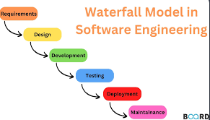

**Applications:**

Small projects with fixed and clear requirements.

Ex: Banking systems and medical applications where no requirement changes are done mid development.

**Advantages:**

* + - Simple layout and easy to understand.

**Disadvantages:**

* + - Not flexible to changes.

**V-Model:**

* + - Extension of waterfall model. It includes a testing phase for each development stage.

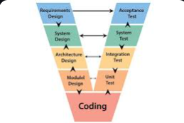

**Applications:** V-model is used where no room for error is allowed.

Ex: Defense and national security systems.

**Advantages:**

* + - * Errors are detected early.

**Disadvantages:**

* + - * Similar to waterfall model in terms of flexibility.

**Incremental model:**

* + - * Development is done in small parts or increments. Each increment adds a new feature or a functionality.

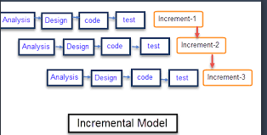

**Applications:**

Situations where requirements are known but each feature can be released in a later stage.

Ex: Mobile payment applications (Paytm)

**Advantages:**

* + - * + Smaller parts/increments leading easier testing.

**Disadvantages:**

* + - * + Requires good planning and design.

**Iterative model:**

* Development is done in repeated cycles called iterations. Each iteration includes all the phases of SDLC from planning till deployment.

**Applications:**

Better suited for complex projects which need constant user feedback.

Ex: Game development.

**Advantages:**

* + - * + Continuous improvement.

**Disadvantages:**

* + - * + Requires constant feedback.

**Spiral model:**

* A combination of waterfall and iterative model.
* Emphasizes risk management.

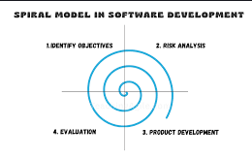

**Applications:**

Complex projects where requirements keep evolving over time.

Ex: Financial system software where regulations need to be revised based on current security protocols.

**Advantages:**

* + - * + Better risk management.

**Disadvantages:**

* + - * + Costly and requires expert risk assessment.

**Agile model:**

* It is again a combination of iterative and incremental model which includes collaboration with stakeholders and small rapid releases.
* It is split into small cycles called sprints.

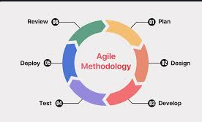

**Applications:**

Continuous development projects

Ex: OTTs (Netflix)

**Advantages:**

* + - * Flexible and adaptive to changes.
      * Provides visibility to stakeholders.

**Disadvantages:**

* + - * Can easily go off track without proper management.

# 7. SCRUM:

Scrum is a project management tool used in Agile to manage and issues in a project with in a short cycle (Sprint). It can be used to assign roles to all the users depending on their function. It can be used to set a project schedule and define deadlines for each sprint. It can also be used to collaborate with the stakeholders/clients allowing visibility to them over the status of the project.

# 8. SPRINT:

A sprint is a fixed time frame set by a team to be able to achieve a defined goal. It usually ranges from one week to 4 weeks depending on the size/complexity of the deliverable.

# 9. Do’s and Don’ts in a sprint:

# 

**What to do in Sprints:**

* Plan according to priorities.
* Set clear goals/expectations for a sprint.
* Learn from sprint reviews.

**What not to do in Sprints:**

* Do not rush a schedule.
* Do not over commit to any goal.
* Do not over schedule work for a single sprint.

# 10. Stories and Backlogs

**Stories:** A user story in Agile refers to a certain feature or functionality desired by the user.

**Backlog:**  A Backlog is list of all items sorted priority wise through which the team can deliver value to a goal. It also includes user stories.

# 11. Scrum Artifacts:

Scrum artifacts are the pieces of information with in scrum that can be used to track progress, manage work and maintain transparency to all teams and stakeholders throughout the development process.

**Product Backlog:** Product backlog id the prioritized list of work items taken from the overall product roadmap.

**Sprint Backlog:** It is a subset ofproduct backlogand it lists the work items from with thin the specific sprint

**Increment:** An increment with in agile is a product or goal or a deliverable created or delivered during each sprint.

**Burn-down chart:** A burn-down chart is graphical representation of the work left Vs. the time.

# 12. Ports and Protocols:

Protocols are the set of rules which define how data is transmitted, received and formatted over a network leading to effective and efficient communication.

Ports are virtual channels which allow different applications and services to use internet without interfering with each other. Each port is identified by a unique number.

# 13. Different network types:

LAN: Local Area network.

WLAN: Wireless local area network.

WAN: Wide area network.

MAN: Metropolitan Area network.

VPN: Virtual private network.

# 14. Types of servers:

* Web servers: These servers host websites and web applications and are responsible for delivering web pages to user’s browsers.
* Database servers: These are dedicated servers whose function is to store and manage data.
* Mail servers: Handle sending, receiving and storing email messages.
* File servers: Provide centralized storage and sharing of files across a network.
* Application servers: Host and manage functioning of applications acting as bridge between front-end and back-end systems.

# 15. Domain Name System (DNS):

* A Domain Name System (DNS) is responsible for turning domain names into IP addresses, which then allows the web browsers to get to the specific web page. Its also called as phonebook of the internet enabling users to access the webpages without using their complex IP addresses.

# 16. Types of network topologies:

* **Bus topology:** All devices connected to a single shred cable. Simple and cost effective but non-efficient for large number of devices due to collisions.

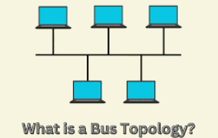

* **Star topology:** All devices connected to a central switch or a hub. Easy troubleshooting but failure of central hub leads to failure of whole network.

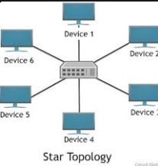

* + **Ring topology:** Each device is connected to two other devices on each side forming a ring like network. Single point failure leads to failure of whole network.

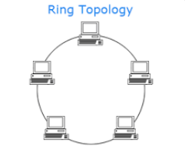

* + - **Mesh topology:** Each device is connected to several other devices creating multiple paths for data transmission forming a reliable network. Although highly reliable, its also costly and difficult to set up.

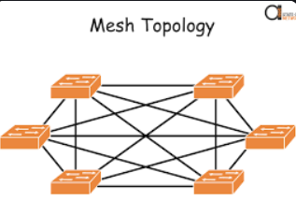

* **Tree topology:** A hierarchal structure of central or root node branching to several nodes below. Although easy to manage and scalable, its also prone to more collisions.

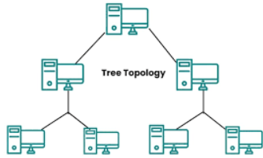

* + **Hybrid topology:** It combines two or more basic network topologies to create amore efficient or flexible network. Requires more skill to implement.

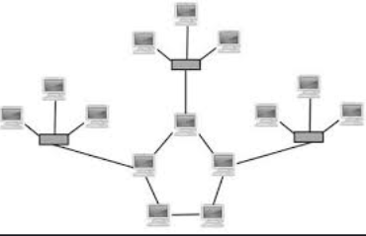

# 17. OSI Model:

The Open systems interconnection model (OSI) is a conceptual framework that divides network communication functions into 7 layers accordingly. The 7 layers of OSI model are as follows:

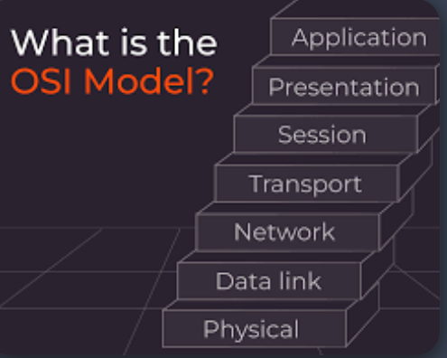

* Application layer: This is the first interaction layer between the human-computer and the network services.
* Presentation layer: Takes care of data formatting ang data encryption.
* Session layer: Maintains connection and is also responsible for controlling ports and sessions.
* Transport layer: Transports data using ani transmission protocols such as Transmission control protocol (TCP) and User Datagram protocol (UDP).
* Network layer: The [network layer](https://www.cloudflare.com/learning/network-layer/what-is-the-network-layer/) is responsible for facilitating data transfer between two different networks.
* Data link layer: The data link layer is very similar to the network layer, except the data link layer facilitates data transfer between two devices on the same network.
* Physical layer: This layer includes the physical equipment involved in the data transfer, such as the cables and [switches](https://www.cloudflare.com/learning/network-layer/what-is-a-network-switch/).